Reversing a word

<https://github.com/fabricesoffack/Python-codes.git>

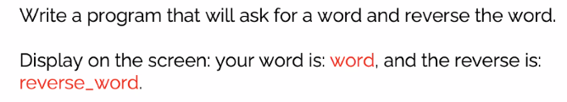

# slicing method

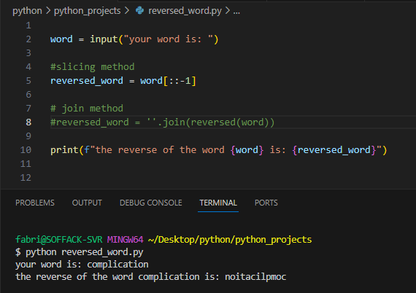

# Join method

